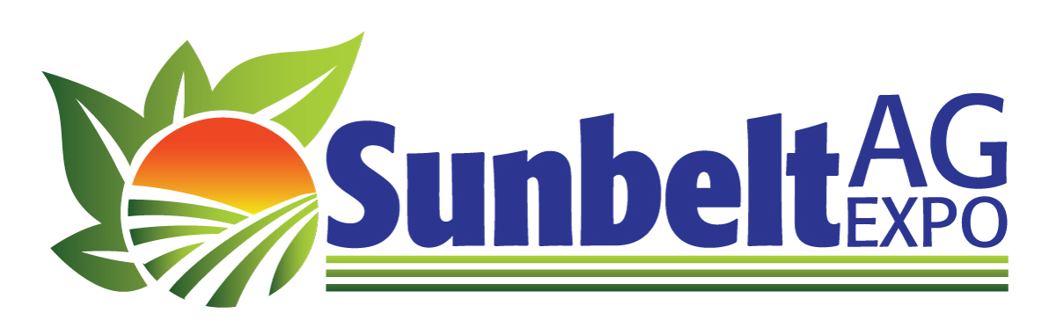
2020 Strategic Plan
News Release
Contact: Becca Turner
229-985-1968
Email: becca@sunbeltexpo.com

For Immediate Release

SUNBELT AG EXPO PLANS FOR SUCCESS IN THE FUTURE

Having completed 42 years of putting on North America’s Premier Farm Show, the Sunbelt Ag Expo board and staff looks forward to continuing the tradition of bringing the latest technology and agricultural advancements to the those in the Southeastern United States. Early last spring, the Expo embarked on a journey to develop a strategic plan that would lead the organization on a path of even greater success during the next decade. With the help of Georgia’s Rural Center and UGA’s Center for Agribusiness and Economic Development (CAED), an economic impact study was completed, and the strategic plan was formulated. The final plan works to tell the story of the Expo and shape the future of the entity.

The Sunbelt Ag Expo, located in Moultrie, Georgia, attracts attendees from across the southeast region, some even traveling from across the country, to engage and learn about agriculture’s latest technology and innovations. Thus, the staff at the Expo saw a need to complete this project in order to continue to fulfill the mission and ensure the strength and longevity of the Expo.

For the first part of the project, CAED faculty completed the quantitative data collection for the economic impact study during the 2019 Sunbelt Ag Expo. Data revealed the Expo has a $16.72 million impact in economic output for a 20-county region in South Georgia. In addition, the study projected a $1.1 million impact on state and local tax revenue during the main event in October each year.

Next, Georgia’s Rural Center staff completed a comprehensive strategic plan to accompany the economic impact assessment. Staff members engaged with key stakeholders of the Sunbelt Ag Expo to gain a clear vision of what the future plans might look like. Many interviews and a survey were conducted during fall 2019. Taking into consideration the qualitative data gathered, the Rural Center compiled key results and worked through short, mid, and long-term goals for the future with objectives to help reach those goals.

To learn more about the results, visit www.sunbeltexpo.com

###

